**Problem Statement:**

Vrinda Store wants to create an annual sales report for 2022.So that Vrinda can understand their customers and grow more sales in 2023.

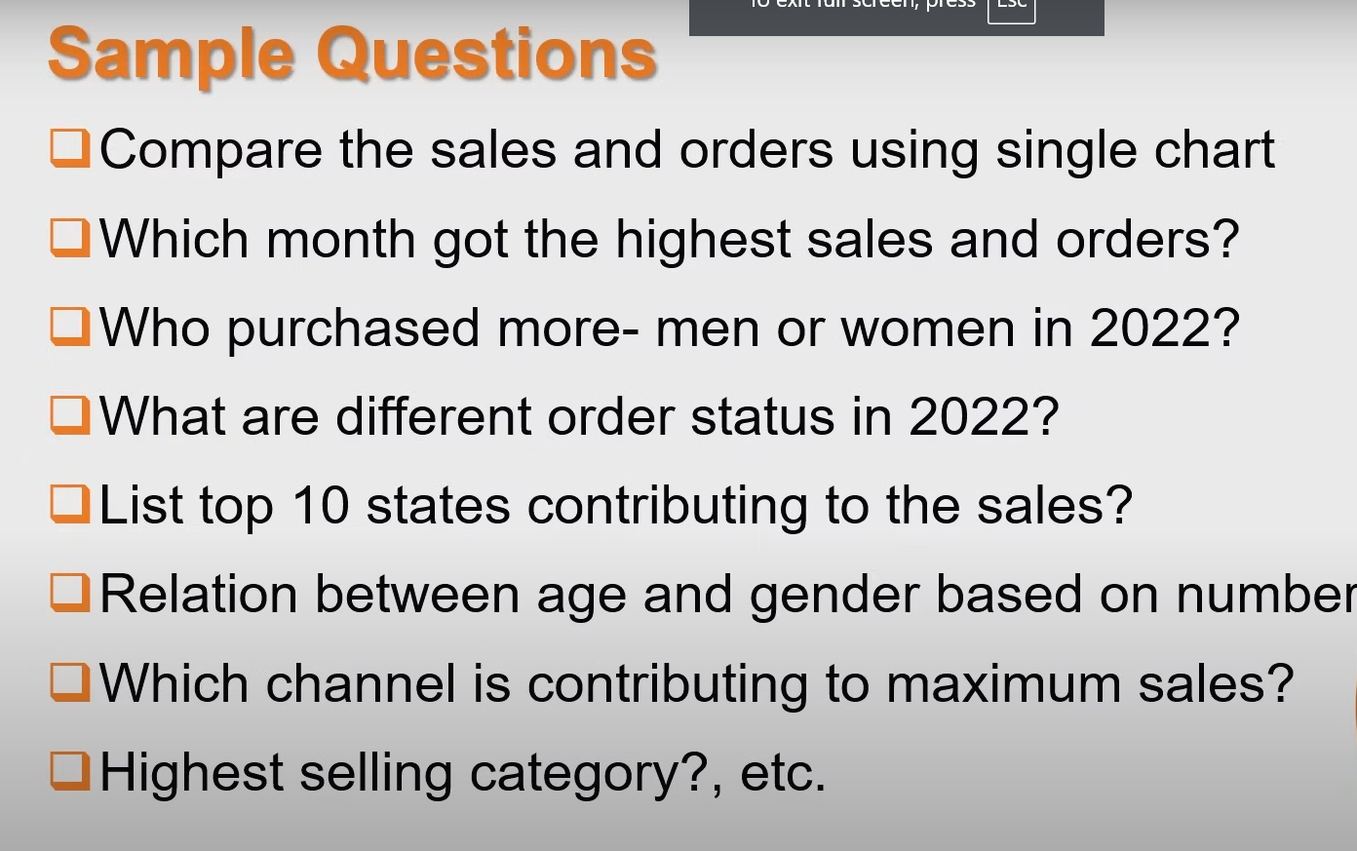

**Conclusion:**

1. Women are more likely to buy as compared to men (65%)
2. Maharashtra, Karnataka and uttar pardesh are the top 3 states (35%)
3. Adult age group (30-49 years) is max contributing (80%)
4. Amazon , flipkart and myntra channels are maximum contributing (80%)

**Final conclusion to improve Vindra store sales:**

Target women customers of age group (30-49 years ) live in Maharashtra, Karnataka and uttar pardesh by showing ads/offers/cupons available on amazon , Flipkart and myntra